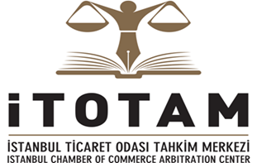

OPENING OF THE ISTANBUL CHAMBER OF COMMERCE ARBITRATION CENTER (ITOTAM)
and
THE PRESENTATION OF THE ARBITRATION RULES

12 May 2015- Istanbul

Istanbul Chamber of Commerce

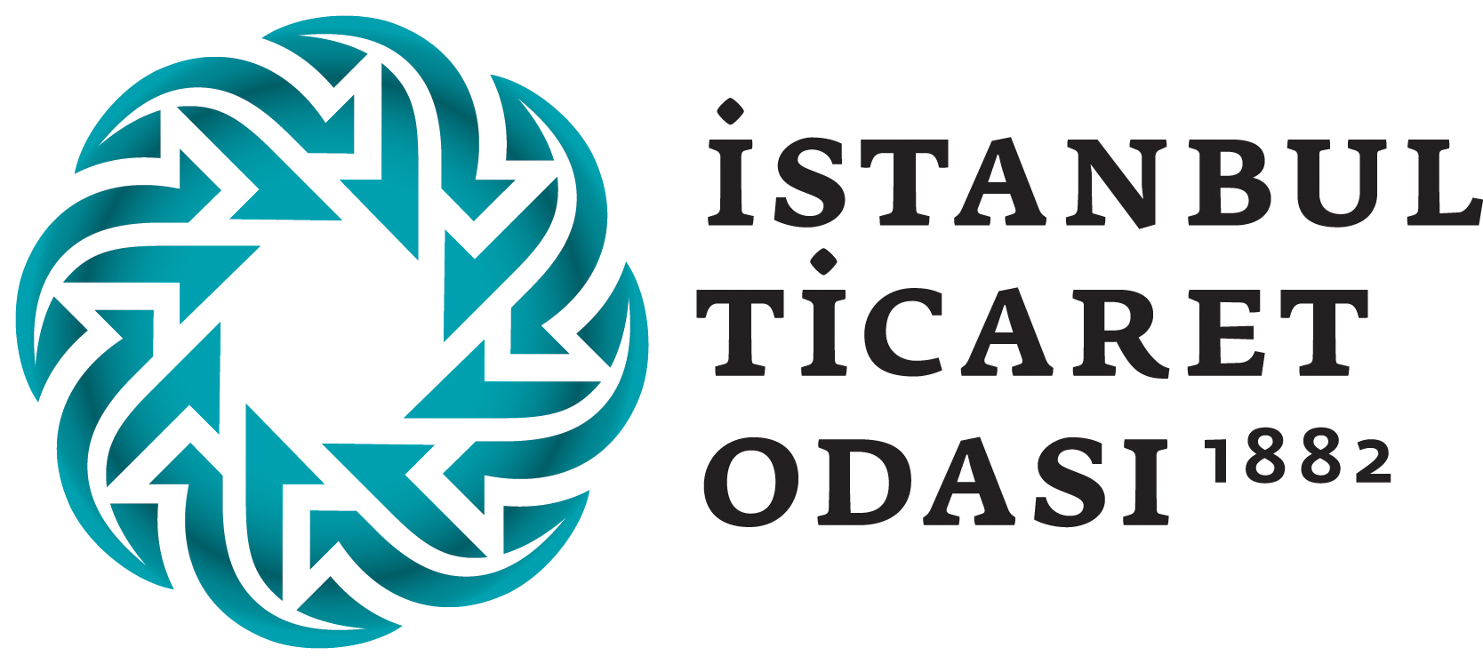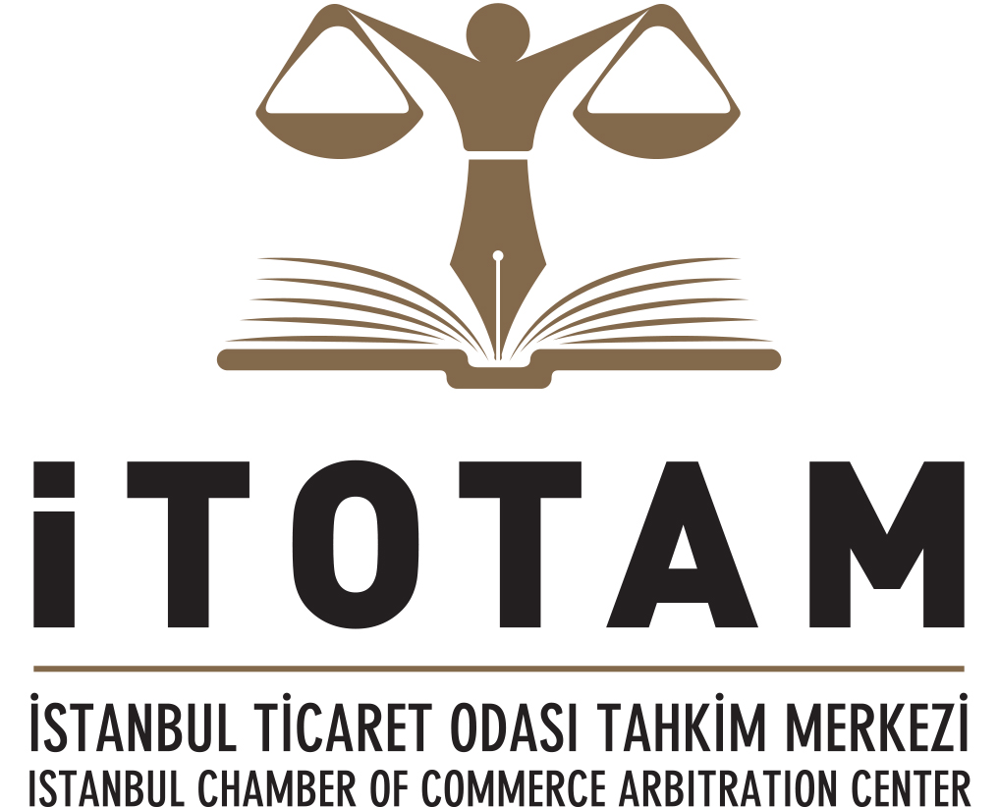

Programme

13.30 – 14.00 Registration

14.00 –14.10 Welcome and Opening Greetings

Murat Kalsım, Vice- President of Executive Board of the Istanbul Chamber of Commerce, Istanbul

Chairman: Prof. Dr. Hakan Pekcanıtez, Galatasaray University , ITOTAM President of Arbitration Court

14:10-14:20 Nimet Baş, Attorney At Law, ITOTAM Arbitration Court Member

14:20-14:40 Prof. Dr. Ergun Özsunay, Istanbul University (Em), Istanbul Chamber of Commerce Legal Advisor

“Development of Arbitration in Turkey”

14.40-15.00 Prof. Dr. HakanPekcanıtez, Galatasaray University, ITOTAM President of Arbitration Court)

“Institutional Arbitration in Turkey “

Chairman: Prof. Dr. İlhanHelvacı , Istanbul University, ITOTAM Vice-President of Arbitration Court

15.00-15.20 Assoc. Prof Ali Yeşilırmak , City University of Istanbul, ITOTAM Arbitration Court’s Member

“ITOTAM Arbitration Rules”

15.20–15.40 Assoc. Prof EbruŞensöz Malkoç, İstanbuL Commerce University, ITOTAM Arbitration Court’s
Member

“Enforcement of Awards Rendered According to ITOTAM Arbitration Rules and Recourse Against Awards”

15.40 –16.00 Q&A

16.00-17:30 Kokteyl

