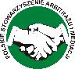
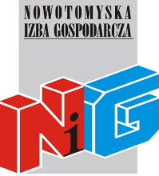

Current Issues in International Commercial Arbitration, Mediation and the Turkish Perspectives

Istanbul, 11-12 May 2015

Assembly Room, Istanbul Chamber of Commerce
Reşadiye Cad. 34112 Eminönü, Istanbul

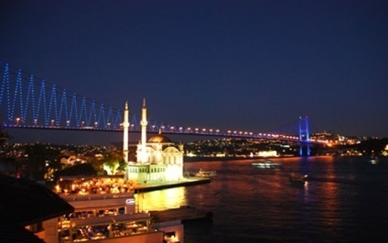

“Current Issues in International Commercial Arbitration, Mediation and the Turkish Perspectives”

Programme

11.05.2015

9.30 – 10.00 Registration

10.00 –10.20 Welcome and Opening Greetings

Hasan Erkesim, Executive Board Member of the Istanbul Chamber of Commerce, Istanbul

Włodzimierz Brych - President of the Court of Arnitration at Nowy Tomyśl Chamber of Commerce, Chairman of Polish Association for Arbitration and Mediation

Session I

Chairman: Prof. Mykola Selivon, President of the International Commercial Arbitration Court and Maritime Arbitration Commission at the Ukrainian Chamber of Commerce

10.20–10.40 Ergun Özsunay, Professor of Law ,Legal Counsel to the Istanbul Chamber of Commerce, Turkey
The Role of State Courts in International Commercial Arbitration under Turkish Law (by Ergun and Murat R.Özsunay)

10.40 – 11.00 Włodzimierz Brych - President of the Court of Arbitration at Nowy Tomyśl Chamber of Commerce, Chairman of Polish Association for Arbitration and Mediation
Limitations of state interference in arbitration

11.00–11.20 Paweł Pietkiewicz – partner at White & Case | P. Pietkiewicz, M. Studniarek i Wspólnicy – Kancelaria Prawnasp.k.-
Arbitration disputes with participation of Turkish parties in Central and Eastern Europe

11.20 – 11.50 Coffee Break

Session II

Chairman: Ergun Özsunay, Professor of Law ,Legal Counsel to the Istanbul Chamber of Commerce, Turkey

11.50 – 12.10 Senem Bahçekapılı Vincenzi, Secretary General of ITOTAM
Arbitration Rules 2014 of ITOTAM

12.10 – 12.30 Prof. Mykola Selivon, President of the International Commercial Arbitration Court and Maritime Arbitration Commission at the Ukrainian Chamber of Commerce (Ukraine)
The legal status of arbitrators under the laws of Ukraine

12.30 – 12.50 Piotr Nowaczyk - Attorney, international arbitrator, representative of the Republic of Poland at the ICC in Paris, partner at DENTONS in Warsaw
The position of an international arbitrator - profession, mission or career?

12.50- 13.10 Prof. Günseli Öztekin Gelgel, Chair of Private International Law at the University of Istanbul School of Law
The Legal Status of Arbitrators Under the Laws of Turkey

13.10- 13.30 Q&A Open floor for discussion and comments from the audience

13.30- 14.30 Lunch

Session III

Chairman: Piotr Nowaczyk - Attorney, international arbitrator, representative of the Republic of Poland at the ICC in Paris, partner at DENTONS in Warsaw

14.30 – 14.50 Yusuf Bozorovich Nazarov– Attorney, Director of “Adolat Soqchisi” Law Office, Ph.D.Professor (Uzbekistan).
Legal regulation of arbitration in the Republic of Uzbekistan and Perspectives for its Development

14.50 – 15.10 Ryszard Wargin - Attorney (Poland)
Turkey as an increasing in value country in international relations and role of arbitration / mediation in securing the thoroughness of economic turnover

15.10 – 15.30 Yadze David Ghochevich - Arbitrator of the Arbitration Court of the Southern Federal District of the Russian Federation (Russia)
The Relevance of Deveopment of Arbitration Proceedings and Mediation in Russia

15.30- 16.00 Q&A Open floor for discussion and comments from the audience

12.05.2015
Session IV

Chairman: Włodzimierz Brych - President of the Court of Arbitration at Nowy Tomyśl Chamber of Commerce, Chairman of Polish Association for Arbitration and Mediation

10.00– 10.20 Paata Kopaleishvili - Director of the Court of Arbitration at Chamber of Commerce and Industry of the Autonomous Republic of Ajara (Georgia)
Alternative Fulfilment as a Component Part of ADR and its Advantages in the Georgian Jurisdiction

10.20 – 10.40 Feyza Eker Ayhan, Deputy Secretary General of ITOTAM
Contemporary Issues in the Field of Turkish Mediation Law

10.40 – 11.00 Angela Mita Baciu PhD, Lawyer at the Bar Association of IASI, Lecturer in Law at «Petre Andrei» University Of Iasi - Romania
The Impact Of The Latest Regulations On Mediation On The Judiciary System In Romania

11.00 – 12.00 Discussion, Closing Remarks and Farewell

12.00- 13.00 Lunch

